RS485 & RS422 COMMUNICATIONS PCB

- PARTS:

QUANTITY: PART #: NOMENCLATURE: LENGTH:

1 PER MACHINE 217065- PCB, BLANK, RS485 & RS422 COMM. N/A

11 PER MACHINE 13520- CAP., CER., .1μF, 50V N/A

1 PER MACHINE 13521- CAP., CER., .01μF, 50V N/A

1 PER MACHINE 14046- CAP., ELEC., 220μF, 16V N/A

1 PER MACHINE 12001- DIODE, 1N4154 N/A

1 PER MACHINE 17626- CONNECTOR, PCB HEADER N/A

1 PER MACHINE 17543-3 HEADER, 3-PIN, METHODE N/A

1 PER MACHINE 17635-3 CONNECTOR, PLUG, D-SUB, 9-PIN N/A

2 PER MACHINE 17636-3 CONNECTOR, RECEPTACLE, D-SUB N/A

4 PER MACHINE 15348- RESISTOR, 1KΩ, ¼W, 5% N/A

3 PER MACHINE 15364- RESISTOR, 4.7KΩ, ¼W, 5% N/A

2 PER MACHINE 15372- RESISTOR, 10KΩ, ¼W, 5% N/A

2 PER MACHINE 10421- IC, RS232 DRIVER N/A

1 PER MACHINE 10467- IC, RS422 DRIVER N/A

1 PER MACHINE 10468- IC, DIFFERENTIAL DRIVER N/A

1 PER MACHINE 10469- IC, TIMER OSCILLATOR N/A

- ASSEMBLY:

A. INSERT AND SOLDER ALL PARTS ONTO THE PCB ACCORDING TO DIAGRAM 1.

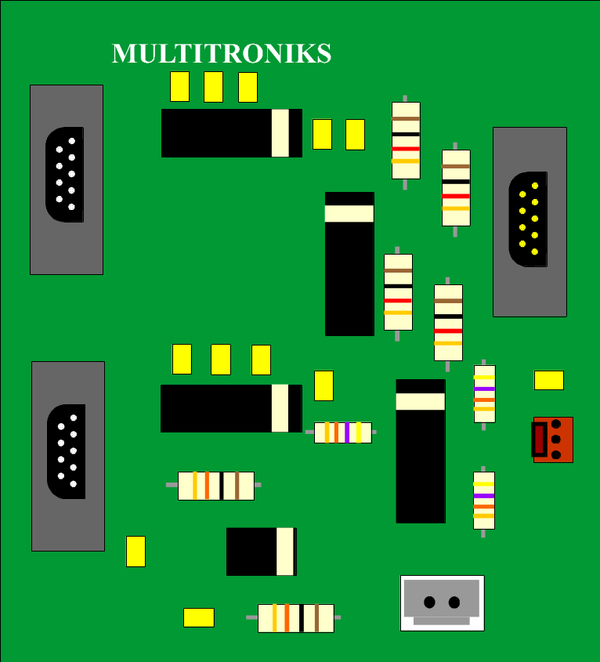

DIAGRAM 1

